2. PRD with tradeoffs
Overview
This section outlines the Product Requirements Document (PRD) feature list for the Financial Fraud Detection System. Each feature includes a description, priority level, and associated tradeoffs to support decision-making and roadmap planning.

Feature List with Tradeoffs
 | Feature | Description | Priority | Tradeoffs
1 | Transaction Scoring Engine | Machine learning model assigns a fraud probability score to each transaction. | P0 | Higher model complexity improves accuracy but increases latency and compute cost.
2 | Real-Time Scoring API | REST API endpoint for real-time fraud scoring. | P0 | Real-time constraints may limit model size and feature engineering complexity.
3 | Batch Scoring Pipeline | Offline scoring for historical transactions and periodic risk assessments. | P1 | Lower infra cost but no real-time protection; delayed insights.
4 | Explainability (Basic) | Rule-based or model-derived explanations for flagged transactions. | P0 | Simple explanations are fast but shallow; may not satisfy compliance teams.
5 | Analyst Review Console | UI for fraud analysts to review alerts, explanations, and transaction details. | P1 | Requires additional engineering and UX work; not essential for MVP.
6 | Policy-Grounded Explanations (RAG) | Retrieve relevant internal policies to justify fraud decisions using RAG. | P1 (V2) | Requires curated policy corpus, vector DB, and LLM costs.
7 | Agentic Investigation Workflow | Multi-step AI agent that gathers context, retrieves cases, and recommends actions. | P2 (V2) | High complexity; requires guardrails, monitoring, and observability.
8 | Model Monitoring & Drift Detection | Track model performance, data drift, and alert analysts. | P1 | Requires additional infra and periodic retraining workflows.
9 | Data Privacy & Masking | PII masking, tokenization, and secure data handling. | P0 | Limits what can be sent to LLMs; increases engineering overhead.
10 | Multi-Channel Fraud Support | Extend detection to ACH, wires, wallets, and other payment channels. | P2 | Complex schemas and feature engineering; increases scope significantly.

Summary
This PRD feature list provides a structured view of the system's functional scope, balancing immediate needs (real-time scoring, explainability, privacy) with advanced capabilities (RAG, agentic workflows, multi-channel support). It supports phased delivery through Version 1 (core ML system) and Version 2 (GenAI-enhanced system).

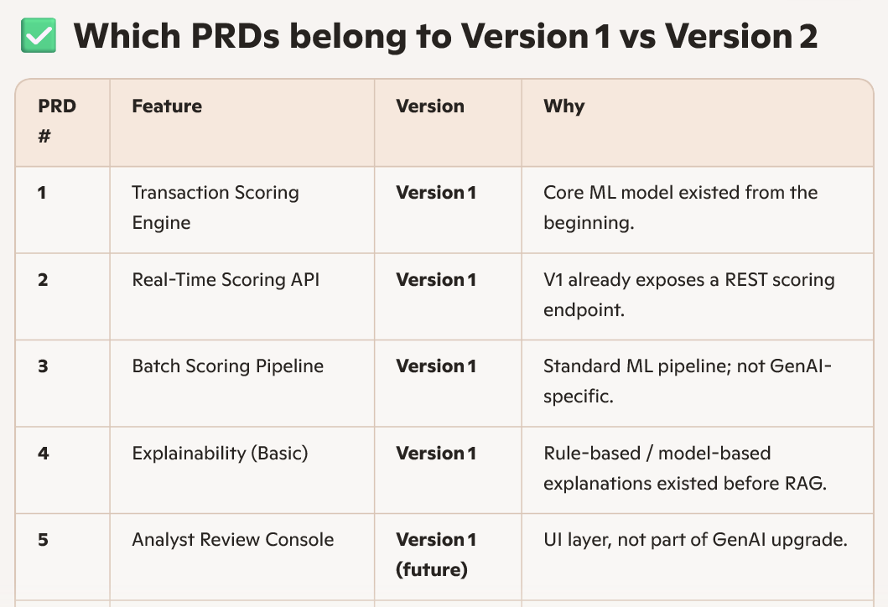
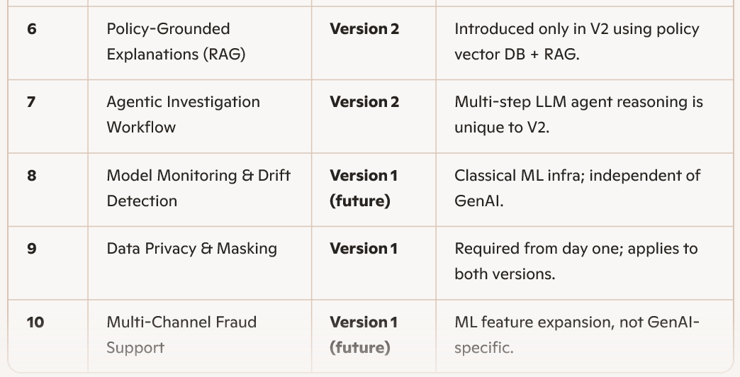
Version 1 includes:
- ML fraud scoring engine
- Real-time scoring API
- Batch scoring
- Basic explainability
- Analyst console (future)
- Model monitoring (future)
- Data privacy & masking
- Multi-channel support (future)
These are all traditional ML system features.
Version 2 adds only two new PRDs:
- PRD 6 — Policy-grounded explanations using RAG
- PRD 7 — Agentic investigation workflow
These are the GenAI + RAG + LangChain + Agentic AI upgrades.
Only PRD 6 and PRD 7 belong to Version 2. All other PRDs are Version 1.

